# UML ALBUM

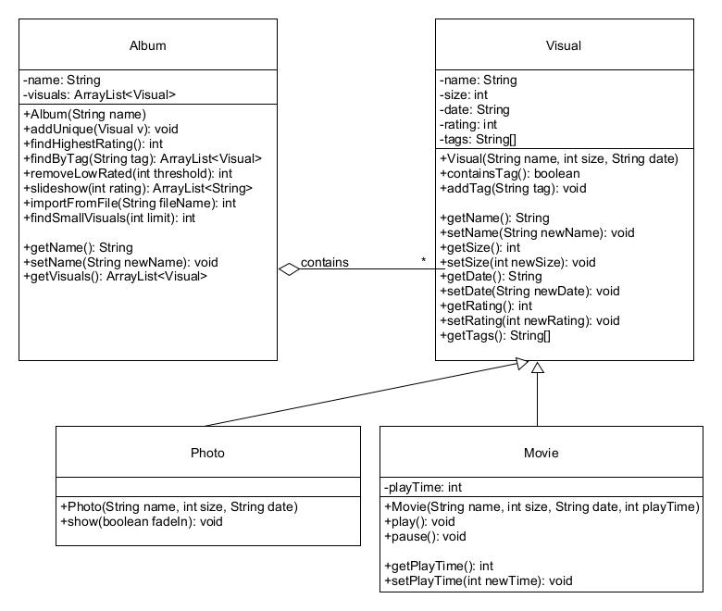

# UML FESTIVAL with inheritance

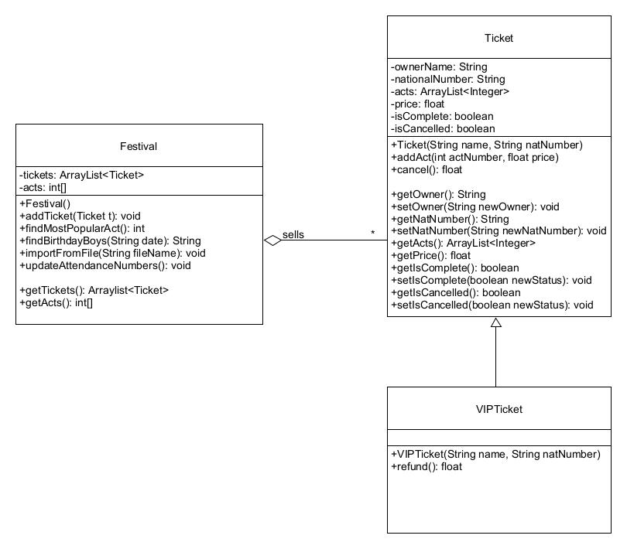

Depending on your interpretation   
VIPTicket extends Ticket or is stored  
as a boolean (see next solution).

In this solution, the acts are assumed to   
be numbered 0,1,2… so the act number  
can serve as the index in the int[ ]. The  
actual values stored are then the   
attendance numbers.

You could also define a 2D-array that   
stores act numbers and their attendance   
number, you could use another   
collections, …

# UML FESTIVAL without Inheritance

Here the refund() logic from the previous solution would be included in cancel() and executed if the boolean isVIPTicket is set to true.   
Notice the difference with the Album and Bibliography exercise, where subclass-specific fields and/or subclass-specific methods   
guide you more towards a solution with Inheritance.

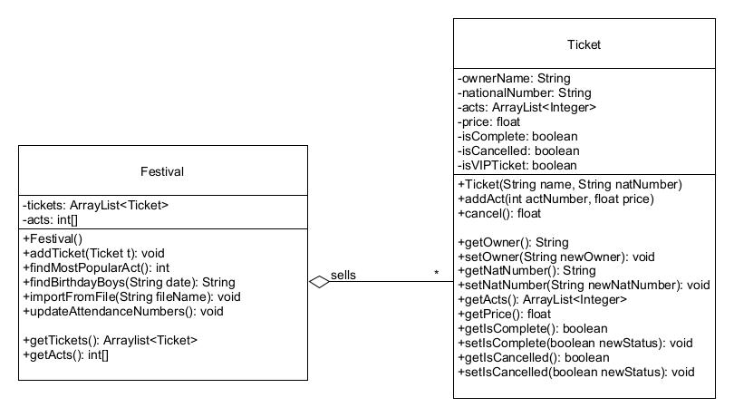

# UML BIBLIOGRAPHY

